

MYSQL
COMP6041_26212 Introduction to Databases

Student ID: R00201303
Name: Laiba Asif
Date: 03.04.2022
Group: COMP1D-Y

Question 3: Implement the design from steps 1 &2 on your MySQL server.
- Create the database: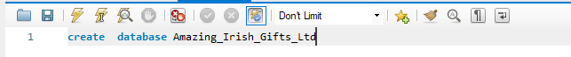 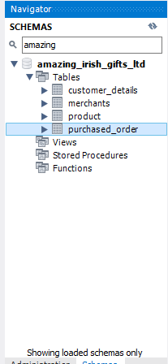
- Create tables: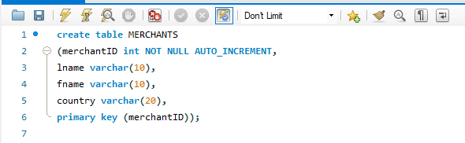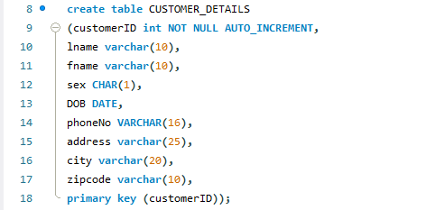 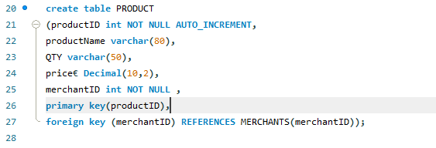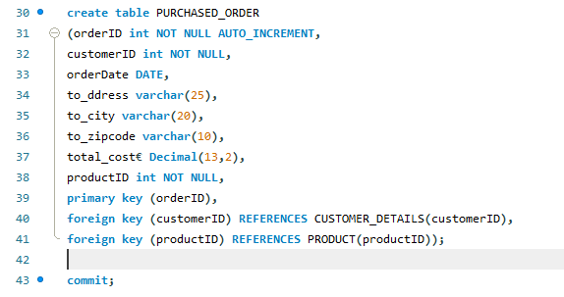
- Implement Drop tables:

DROP TABLE `amazing_irish_gifts_ltd`.`product`
DROP TABLE `amazing_irish_gifts_ltd`.`purchased_order`

Question 4: Devise sample data i.e. make up at least 4 rows of data for each table.
- Insert values to the tables: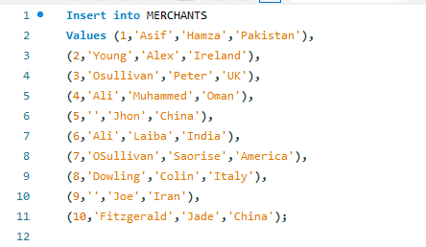 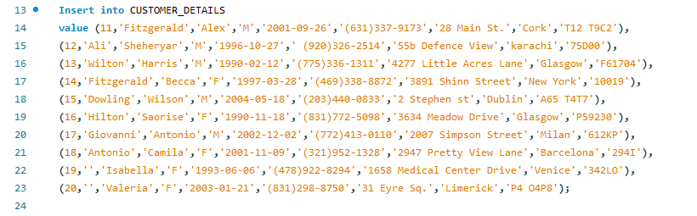 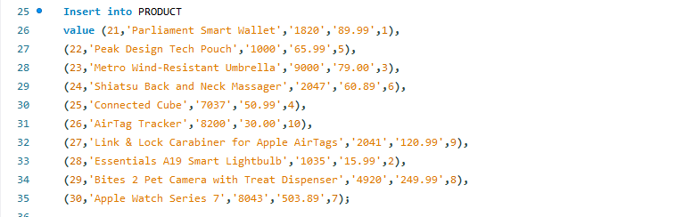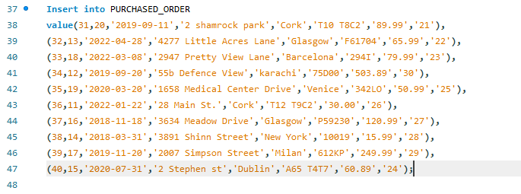
- Run the tables to show data:
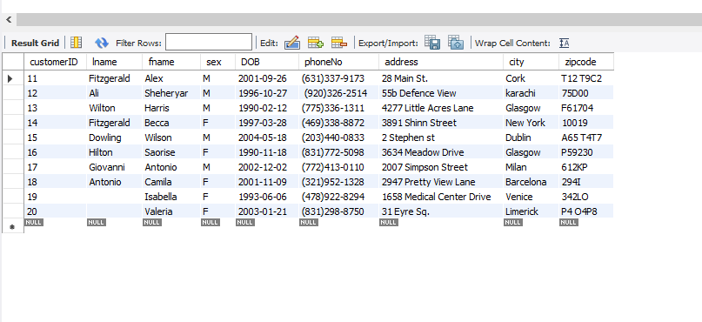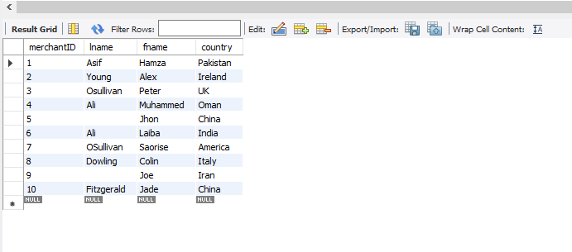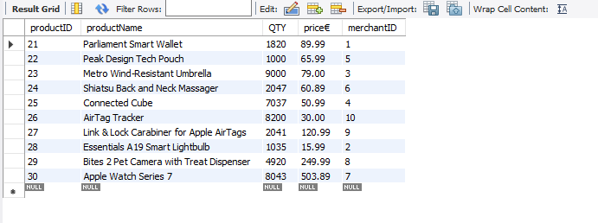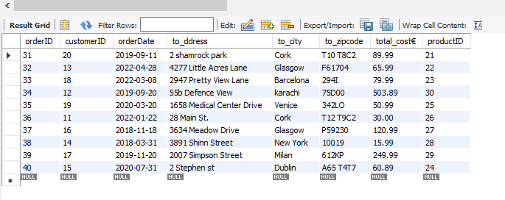
Question 5: Write 4 SQL multi-table JOIN queries that demonstrate the functioning of your database design.
1. 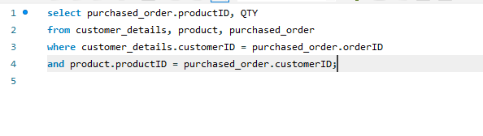
2. 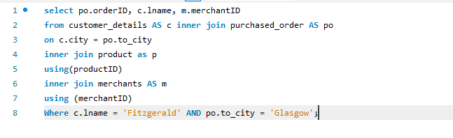

3. 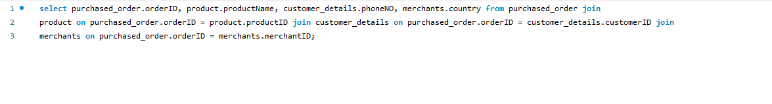
4. 